
For Immediate Release | Contact: Sameera Jordan
June 17, 2026 | Media Relations Manager
 | Sameera.Jordan@BankWithUnited.com

United Bank Welcomes Jimmy Kimbell as Greenville, South Carolina Market President
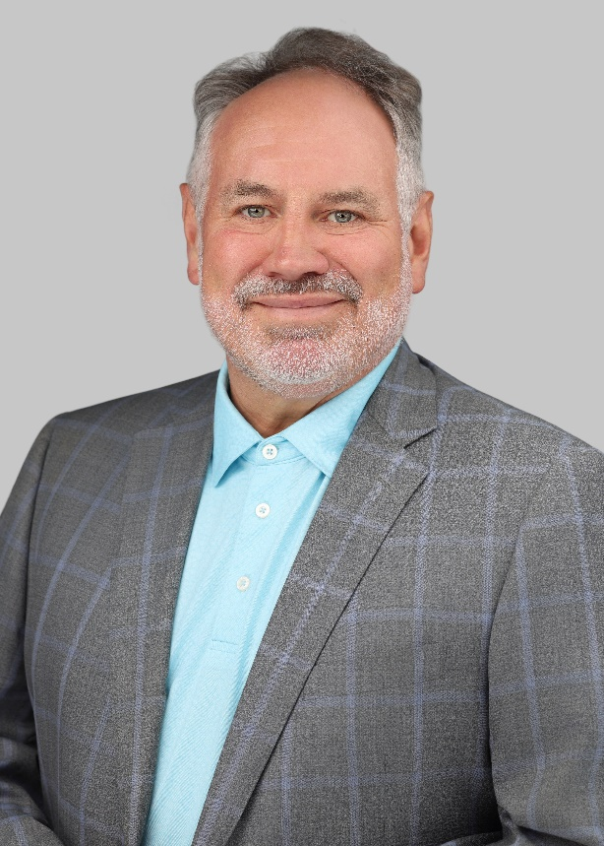
GREENVILLE, S.C. – United Bank recently welcomed Jimmy Kimbell as the new Greenville market president. In this role, Kimbell will lead strategic efforts to drive commercial and retail production while ensuring the market's profitability and sustained growth. Additionally, Kimbell will play a pivotal leadership role in managing public relations efforts in Greenville, while also representing United Bank in the community through active participation in civic affairs and professional organizations.

“Upstate South Carolina has become one of the fastest growing industrial hubs in the Southeast, making it a very attractive growth market for United,” said United Bank Regional President Marshall Cooper. “Jimmy’s hiring signifies an exciting next step in the growth of the Bank’s broader Carolinas region, as we continue to invest in our people and business operations in the South. We believe Jimmy’s decades of experience, extensive history in the region, and expertise in relationship banking will be immensely valuable for United.”

Kimbell will be based in United’s Poinsett office in Greer. Comprised of five United Bank branches, the Greenville Market covers Oconee, Pickens, Greenville, Spartanburg, Cherokee, Union, Laurens, Greenwood, Abbeville, and Anderson counties in South Carolina. Kimbell’s hiring reaffirms the Bank’s continued commitment to its Greenville Market.

Kimbell has over 35 years of experience in the financial services industry with an extensive background leading commercial banking operations and driving growth. Prior to joining United, he held numerous executive leadership roles at community banking institutions across the state, including experience as president and chief executive officer, senior vice president, and regional executive.

“United Bank excels at maintaining a relationship-focused banking model, while also increasing its size and scale to better serve customers with more sophisticated products and services,” said Kimbell. “Relationships are what have kept me in the banking industry for so long. Being presented with an opportunity like this – to continue serving my community and helping customers find the solutions to their unique financial needs, but now with the resources of a large bank – was a very attractive opportunity for me.”

Kimbell received a Bachelor of Science in Financial Management from Clemson University, and he is a graduate of the American Bankers Association National Commercial Lending School and Stonier Graduate School of Banking. He has been actively involved in the community throughout his career and currently serves as board chairman of the Greeneville Housing Fund and is a board member of Touched by ALS. Kimbell, his wife Amy, and their two children – daughter Lawing and son Jackson, a rising sophomore at Clemson – reside in Greer.

ABOUT UNITED BANK
United Bank is a premier community bank and a subsidiary of United Bankshares, Inc. (NASDAQ: UBSI). United has consolidated assets of approximately $34 billion with over 240 offices located across North Carolina, South Carolina, Georgia, Virginia, West Virginia, Maryland, Ohio, and Pennsylvania, as well as Washington D.C. The Bank is dedicated to growing the relationships it has built since 1839 and offering a competitive suite of banking and lending products, treasury management, wealth management, mortgage services, personal and business credit cards, and more. For more information, visit BankWithUnited.com.

###

